OBSTACLE #1  GATE | 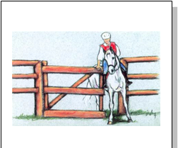  Credit: V. From Saint Vaulry
Equipment/Material Needed for Obstacle  - Two Jump Wings or something similar on which to hang a rope.Jump wing should be 1.4 meters (4 feet) high. Set 2 to 4 meters apart (6 to 12 feet)  - Rope hung from one Jump Wing to the other.  - May use a swinging gate. | Procedures  Same procedure for all levels  - Approach the gate at a walk.  - Open the gate with the left hand.  - Always maintain contact with the gate/rope.  - For a rope gate, the rider may change hands but should not drop the rope.
Demerits or faults counted down  - Refusal to approach the gate.  - Drops the gate or looses contact with the gate.  - Horse rushes through. | Style Rewarded  - Controlled walk  - Fluid  - Horse does not touch gate  - Horse does not exceed the axis of the rider’s shoulders.
PFHA VIRTUAL TRAIL CLASS

OBSTACLE #2  IMMOBILITY IN A CIRCLE | 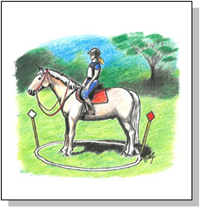
Equipment/Material Needed for Obstacle  - A 2.50 meter (8 foot) circle drawn on a flat ground  - Two pennants/cones. The pennants/cones delineate the entry and exit to the circle. They are positioned 180 degrees apart on the perimeter of the circle | Procedures  Novice Level  - Enter the circle at a walk  - Halt horse in center of circle.  - Remain immobile for 10 seconds. Count out loud, « One thousand one, One thousand two….up to One thousand ten)  - Exit circle at a walk  Medium Level  - Complete Novice steps 1,2,3  - Exécute a 180 degree turn on the haunches  - Exit the circle at a walk  Advanced Level  - Complete Novice steps 1,2,3  - Exécute a 360 degree turn on the haunches  - Exit the circle at a walk
Demerits or faults counted down  - Refusal to enter the circle.  - Stepped on the edges of the circle.  - Did not remain immobile for 10 seconds. | Style Rewarded  - Controlled walk  - Fluid  - Horse remained still for 10 seconds.  Medium Level & Advanced Level  - Hind leg remained stationary as front legs cross over.

PFHA VIRTUAL TRAIL CLASS
PFHA VIRTUAL TRAIL CLASS

OBSTACLE #3  JUMP | 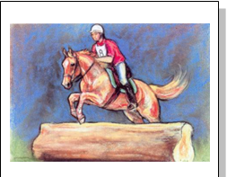  Credit: V. From Saint Vaulry
Equipment/Material Needed for Obstacle  - Jump Pôles 2.5 – 3 meters, (8 – 10 feet) wide  - At Novice level, pôles are set on ground  - At Medium level jump is not to exceed 0.5 meters (22 inches)  - At Advanced level, jump consists of a solid looking obstacle at 0.5 meters (22 inches) | Procedures  Novice Level  - Approach pôles at a walk  - Walk over ground poles  Medium Level  - Approach pôles at a corto  - Jump  Advanced Level  - Approach pôles at a canter  - Jump
Demerits or faults counted down  - Refusal to approach jump/pôles  - Rider imblalanced.  - Rushing the jump | Style Rewarded  - Horse approaches and jumps cleanly, naturally and with assurance.  - Correct position of the rider  - Chest is slightly ahead of vertical  - Rider is balance over stirrups  - Heels down  - Far-off look

OBSTACLE #4  CARRY BETWEEN BARRELS | 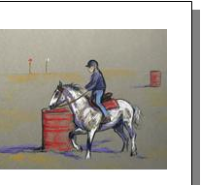  Credit: V. From Saint Vaulry
Equipment/Material Needed for Obstacle  - Two barrels or any flat top item.  - Coat for Novice level  - Bucket half full of water for Medium level.  - Tablespoon and tennis ball for Advanced level | Procedures  Novice Level  - Approach barrel at a largo  - Halt  - Take coat from first barrel.Do not have to put coat on, just lay over saddle.  - Carry to second barrel.  Medium Level  - Approach barrel at a largo  - Halt  - Take bucket from first barrel.  - Carry to second barrel.  Advanced Level  - Approach barrel at a largo  - Halt  - Pick up tablespoon, put ball in tablespoon.  - Carry to second barrel.
Demerits or faults counted down  - Refusal to approach either barrel  - Halt was not square.  - Horse shies when item is picked up.  - Item is dropped | Style Rewarded  - Halt is square. Horse remains still until rider cues to proceed.  - Unhurried as approach barrel.  - Remains still as item is picked up  - Approaches second barrel calmly
PFHA VIRTUAL TRAIL CLASS

OBSTACLE #5  SIDE PASS | Two pole placement for the Advanced Level
Equipment/Material Needed for Obstacle  - Novice and Medium level – One pole 2.5 – 3 meters (8 to 10 feet) long  - Advanced level – Two pôles laid end to end with 3 meters (10 feet) between the pôles. | Procedures  Novice Level  - Horse approaches the pole perpendicular.  - The horse’s legs must cross in a lateral movement over the rail, keeping the rail between the horse’s front and hing legs.  - Horse must side pass down pole in one direction from right to left.  Medium Level  - Same as Novice level 1 & 2.  - Horse must side pass down pole in one direction from right to left but must stop in middle and resume the side pass..  Advanced Level  - Same as Novice level 1 & 2.  - Horse must side pass down one pole.  - Do a 180 degree turn on the haunches in the middle of the two pôles.  - Side pass the second pole.
Demerits or faults counted down  - Refusal to approach the pole(s).  - Horse hits the pôles  - Horse does not remain perpendicular to the pole(s).  - Horse does not keep pole between front and hind feet, Horse steps over the pole.  - Stops without completely side passing the entire pole(s) | Style Rewarded  - Fluid sidewise movement.  - Horse remains perpendicular to the pole  - Horses leg cross evenly  - Rider does not lean. Stays vertical and balanced.

PFHA VIRTUAL TRAIL CLASS

PFHA VIRTUAL TRAIL CLASS

OBSTACLE #6  SLALOM | 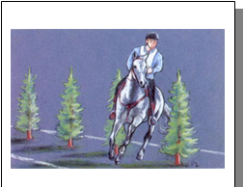  Credit: V. From Saint Vaulry
Equipment/Material Needed for Obstacle  - Five Cones set 7 meters (22 feet) apart. | Procedures  Novice Level  - Slalom through the cônes at a walk.  Medium Level  - Slalom through the cônes at a corto  - Stop after the 3rd cone.  - Slalom the remaining cônes at a corto  Advanced Level  - Same as Medium level 1, 2 & 3.  - Back through the cônes.
Demerits or faults counted down  - Refusal to approach the cônes  - Break gait.  - Touch cônes. | Style Rewarded  - Fluid  - Rider does not lean in.  - Back is fluid with corners rounded

PFHA VIRTUAL TRAIL CLASS

OBSTACLE #7  CHUTE | 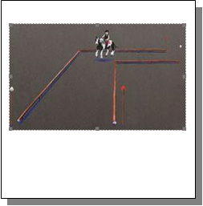  Credit: V. From Saint Vaulry
Equipment/Material Needed for Obstacle  - Pôles to mark the chute .Chute should be 2 meters (6 feet) wide. Could just draw chute on the ground.  - At Novice level, chute is just a straight chute. No turns  - At the Medium level, chute is L shaped  - At the Advanced level, chute is U shaped | Procedures  Novice and Medium Level L Shaped Chute  - Largo through the chute.  - Halt at end of chute  - Back through chute  Advanced Level U Shaped Chute  - Largo through the chute.  - Halt  - Side pass over pole  - Back out  - Exit at a walk
Demerits or faults counted down  - Refusal to enter the chute.  - Steps on pôles  - Rushes through | Style Rewarded  - Fluid  - Remains in gait  - Back is balanced. Horse is not gapping its mouth.

